**0. terraform important commands**

**# Correct the indentation of terraform .tf files**

--- terraform fmt

**# Check errors in syntax**

--- terraform validate

**# Dry run, it won’t execute but it will tell you what happened when you execute the terraform.**

--- terraform validate

**# Execute terraform**

--- terraform apply -auto-approve

**# Destroy infrastructure**

--- terraform destroy -auto-approve

**# List the terraform resources**

--- terraform state list

**# Destroy a particular target**

--- terraform destroy -target aws_vpc.vpc3 -auto-approve

--- **note** – when we say terraform state list then it will list out all the resources created by terraform so, we will list the resources names while destroying the target.

**# If you wish to store the current configuration with no changes to the state**

--- terraform init -reconfigure

**Terraform workspace**

**# List the workspace**

--- terraform workspace list

**# Create new workspace**

--- terraform workspace new dev

**# List the workspace**

--- terraform workspace list

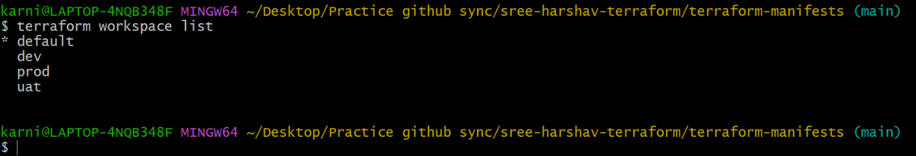

**# Switch workspace**

--- terraform workspace select prod

**# Delete workspace**

--- terraform workspace delete prod

**Remove resource from terraform state file**

--- after dynamo db configuration, we need to reconfigure.

--- **terraform init -reconfigure** -

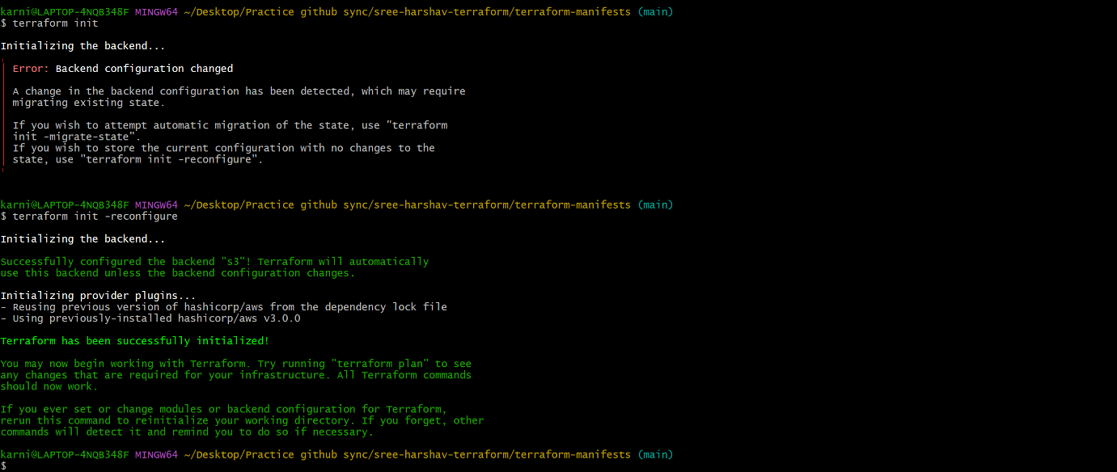

--- **terraform state list** – it will list the resources which is created by terraform.

--- **terraform state rm terraform-state-lock-dynamo** -